Exercise 1: Implementing the Singleton Pattern
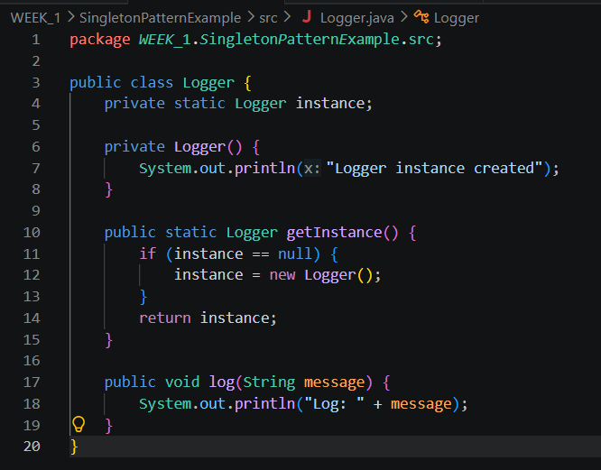
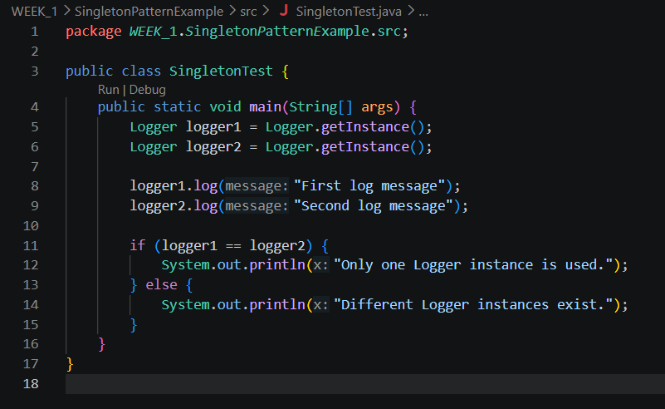
Results:
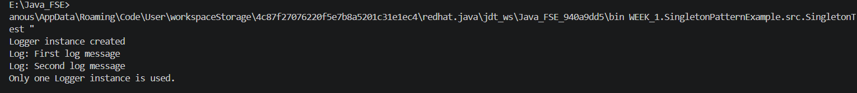
Exercise 2: Implementing the Factory Method Pattern
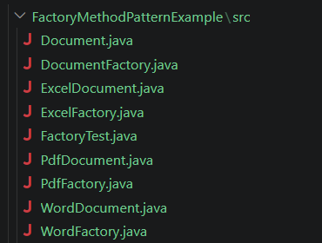
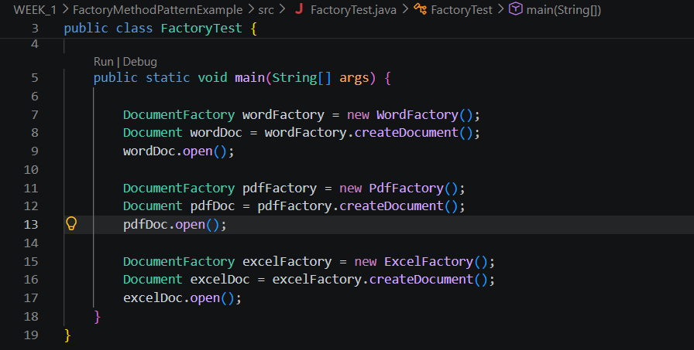
Results:
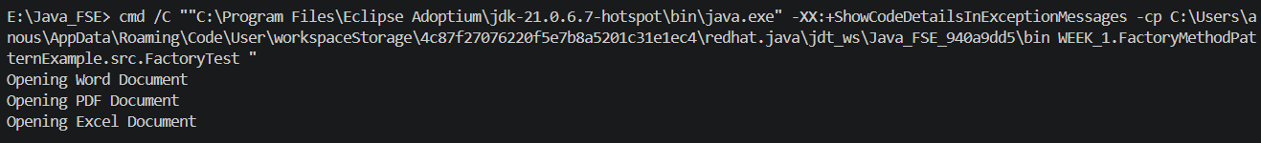

Exercise 2: E-commerce Platform Search Function
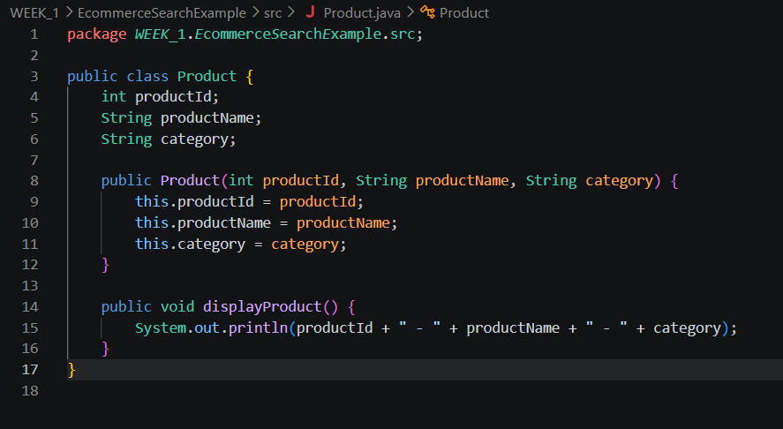
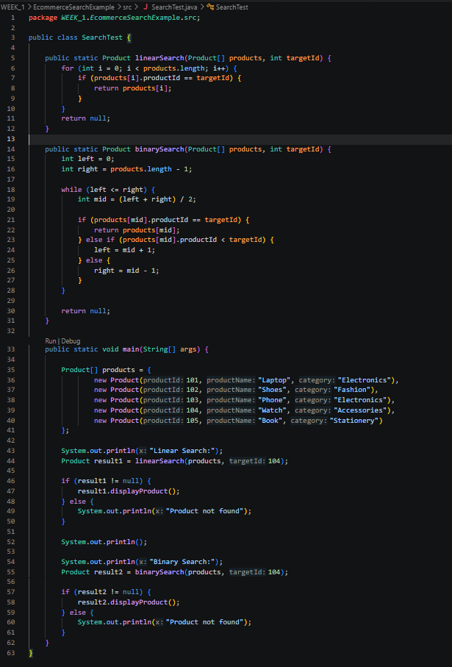
Results:
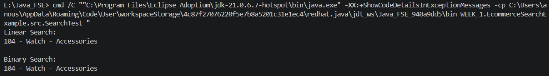
Exercise 7: Financial Forecasting
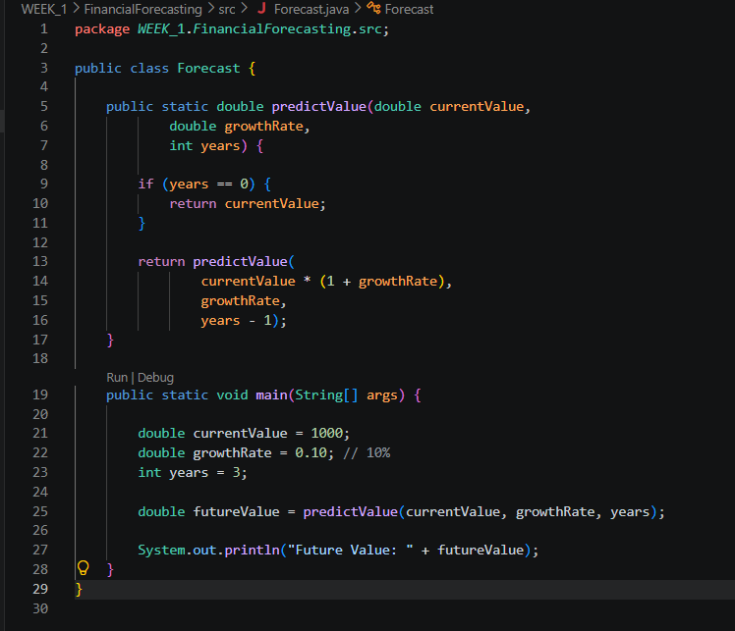
Results:
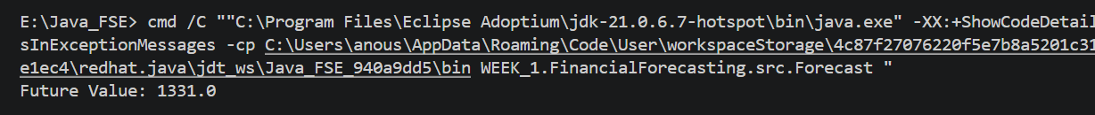

Exercise 1: Control Structures
Scenario 1: Apply 1% discount to loan interest rates
BEGIN
FOR rec IN (
SELECT c.customer_id, l.loan_id, l.interest_rate
FROM customers c
JOIN loans l ON c.customer_id = l.customer_id
WHERE c.age > 60
)
LOOP
UPDATE loans
SET interest_rate = rec.interest_rate - 1
WHERE loan_id = rec.loan_id;

DBMS_OUTPUT.PUT_LINE('Discount applied for Customer ID: ' || rec.customer_id);
END LOOP;

COMMIT;
END;
/
OUTPUT:

Scenario 2: Set VIP flag for customers with balance > 10000
BEGIN
FOR rec IN (
SELECT customer_id
FROM customers
WHERE balance > 10000
)
LOOP
UPDATE customers
SET IsVIP = 'TRUE'
WHERE customer_id = rec.customer_id;

DBMS_OUTPUT.PUT_LINE('VIP status updated for Customer ID: ' || rec.customer_id);
END LOOP;

COMMIT;
END;
/
OUTPUT:

Scenario 3: Print reminders for loans due in next 30 days
BEGIN
FOR rec IN (
SELECT c.customer_name, l.loan_id, l.due_date
FROM customers c
JOIN loans l ON c.customer_id = l.customer_id
WHERE l.due_date BETWEEN SYSDATE AND SYSDATE + 30
)
LOOP
DBMS_OUTPUT.PUT_LINE(
'Reminder: Dear ' || rec.customer_name ||
', your loan ID ' || rec.loan_id ||
' is due on ' || TO_CHAR(rec.due_date, 'DD-MON-YYYY')
);
END LOOP;
END;
/
OUTPUT:
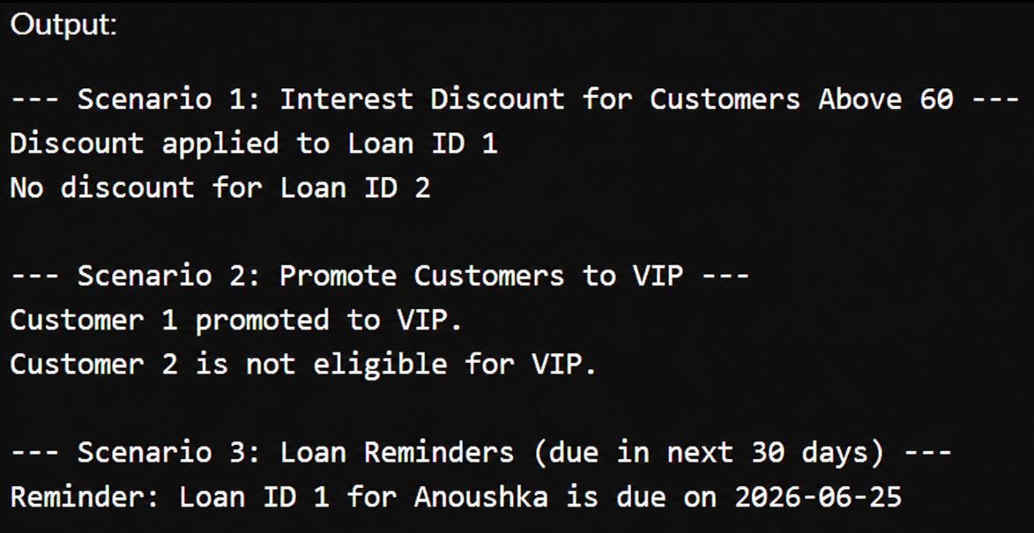
Exercise 3: Stored Procedures
Scenario 1: Process monthly interest for savings accounts

CREATE OR REPLACE PROCEDURE ProcessMonthlyInterest
IS
BEGIN
UPDATE accounts
SET balance = balance + (balance * 0.01)
WHERE account_type = 'Savings';

DBMS_OUTPUT.PUT_LINE('Monthly interest processed for all savings accounts.');

COMMIT;
END;
/
Scenario 2: Update employee bonus by department

CREATE OR REPLACE PROCEDURE UpdateEmployeeBonus(
p_department_id IN employees.department_id%TYPE,
p_bonus_percent IN NUMBER
)
IS
BEGIN
UPDATE employees
SET salary = salary + (salary * p_bonus_percent / 100)
WHERE department_id = p_department_id;

DBMS_OUTPUT.PUT_LINE('Bonus updated for department ID: ' || p_department_id);

COMMIT;
END;
/

Scenario 3: Transfer funds between accounts

CREATE OR REPLACE PROCEDURE TransferFunds(
p_source_account_id IN accounts.account_id%TYPE,
p_target_account_id IN accounts.account_id%TYPE,
p_amount IN NUMBER
)
IS
v_source_balance accounts.balance%TYPE;
BEGIN
SELECT balance
INTO v_source_balance
FROM accounts
WHERE account_id = p_source_account_id;

IF v_source_balance >= p_amount THEN
UPDATE accounts
SET balance = balance - p_amount
WHERE account_id = p_source_account_id;

UPDATE accounts
SET balance = balance + p_amount
WHERE account_id = p_target_account_id;

DBMS_OUTPUT.PUT_LINE('Transfer successful.');

COMMIT;
ELSE
DBMS_OUTPUT.PUT_LINE('Insufficient balance.');
END IF;

EXCEPTION
WHEN NO_DATA_FOUND THEN
DBMS_OUTPUT.PUT_LINE('Invalid account ID.');
WHEN OTHERS THEN
ROLLBACK;
DBMS_OUTPUT.PUT_LINE('Error occurred: ' || SQLERRM);
END;
/
OUTPUT:
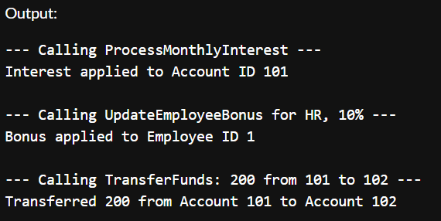
Exercise 1: Setting Up JUnit
RESULTS:
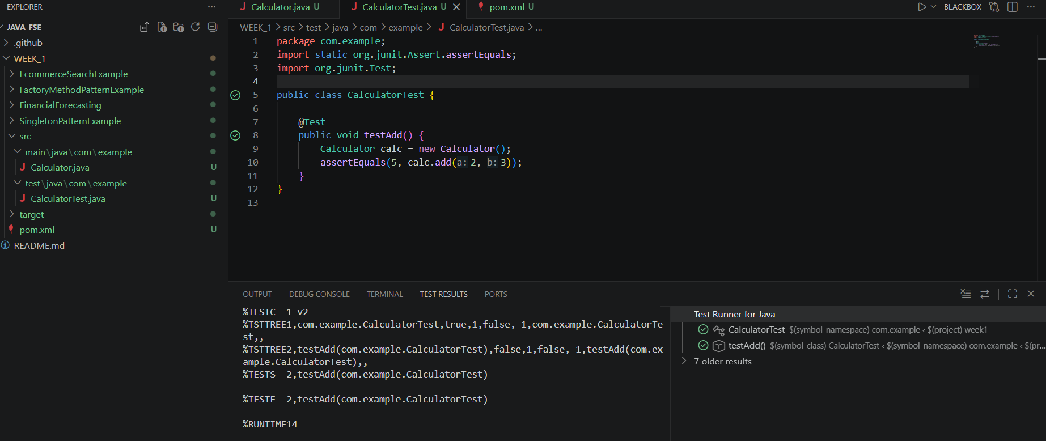
Exercise 3: Assertions in Junit
RESULT:
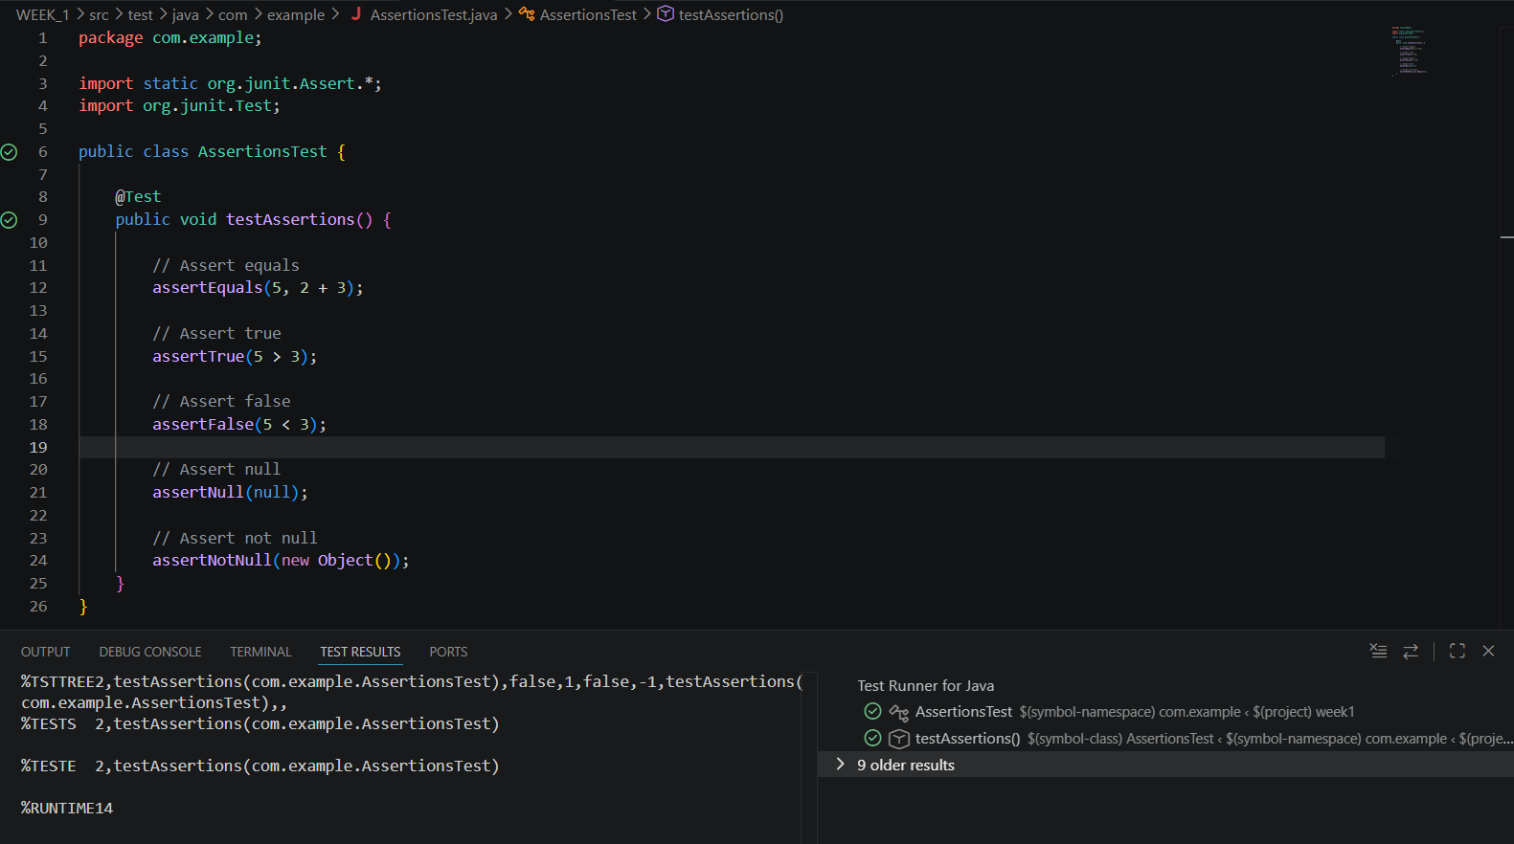
Exercise 4: Arrange-Act-Assert (AAA) Pattern, Test Fixtures, Setup and Teardown Methods in Junit
INPUT:
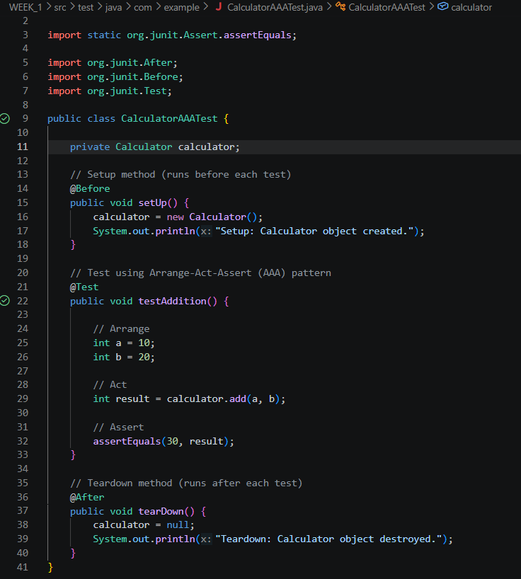
OUTPUT:
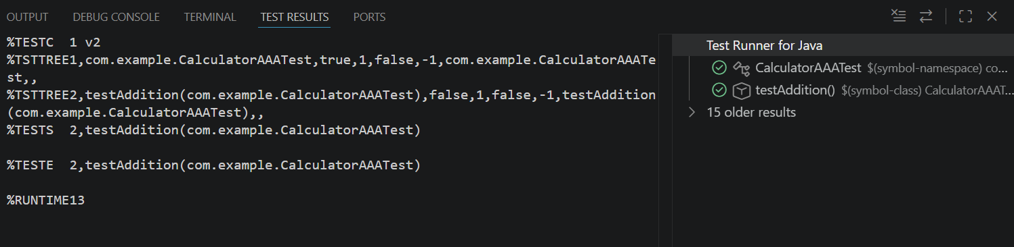
Exercise 1: Mocking and Stubbing
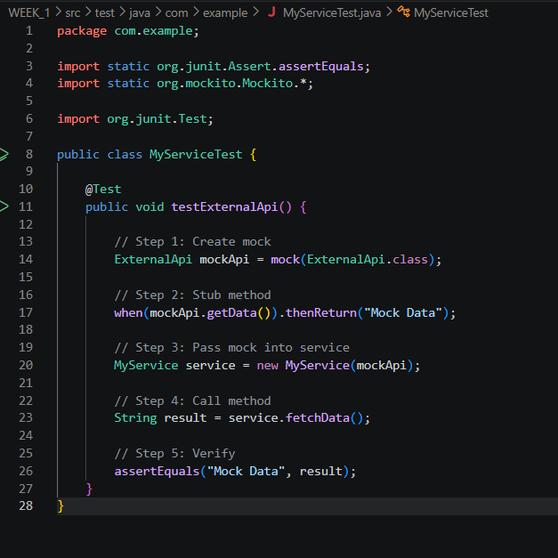
OUTPUT:
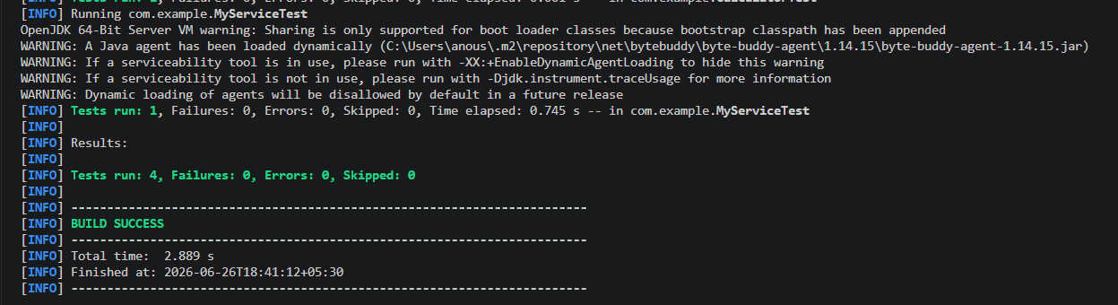
Exercise 2: Verifying Interactions
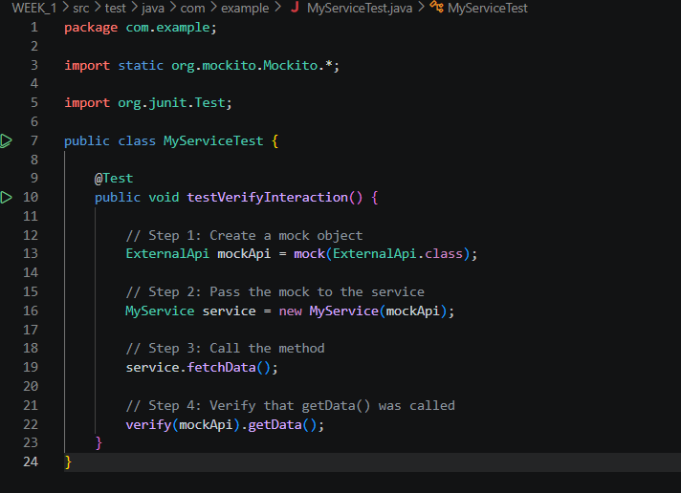
OUTPUT:
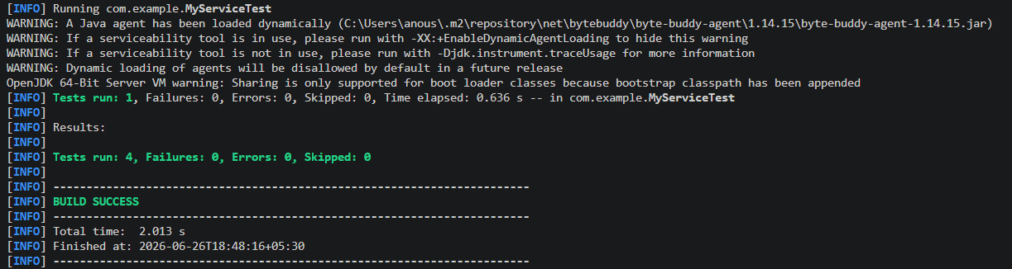
Exercise 1: Logging Error Messages and Warning Levels
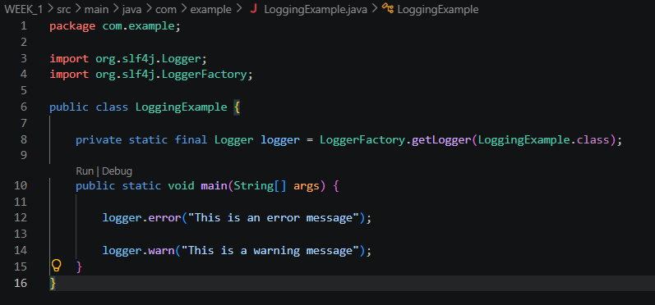
OUTPUT:

